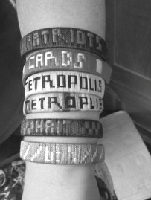

**COMING EVENTS:**

**Wristbands from Haiti:** When the Metropolis 1st youth group returned from Haiti, they brought back wristbands to sell. They were made by 2 men in Haiti who make them as their source of income. One of the men is 22 years old with many family members that he supports by doing odd jobs. The other man is a former voodoo priest who gave up his only means of income when he became a Christian. We have several of these wristbands for sale at the UBA Office. There are a few different colors, but they all say “Haiti” on them. If you would like to purchase one, just call or stop by our office. They are $4 each. All of the money collected will go back to the families that made them.

**SEPTEMBER MISSION ACTION:**

Baptist Children’s Home Fall Festival-September 19th.

We are asking each church to supply items for the Silent Auction at the Fall Festival. These can be homemade craft items, purchased items or quilts for the quilt auction. The deadline for bringing these items to the UBA office, is September 15th. Donated items will be picked up the morning of the 16th for delivery to BCHFS. Labels, identifying the items and donors, are available at our office.

**OCTOBER MISSION ACTION:**

Shoeboxes for Operation Christmas Child. You can drop filled boxes off at Immanuel Baptist Church, 1119 Market St., Metropolis. Times and dates will be in our October newsletter. We have pre-printed shoeboxes available at the UBA Office for 40¢/box.

For the past 25 years, “See You At The Pole” has been about one simple act – PRAYER.

It is about students uniting themselves in prayer, before God, interceding for their generation. All around the globe, in every time zone, students will be gathering at their school flagpoles, praying for their school, friends, families, churches and communities.

Churches, encourage your students to be a part of this national event on Wednesday, September 23 at their school.

“They all met together and were constantly united in prayer.”Acts 1:14

**UBA**

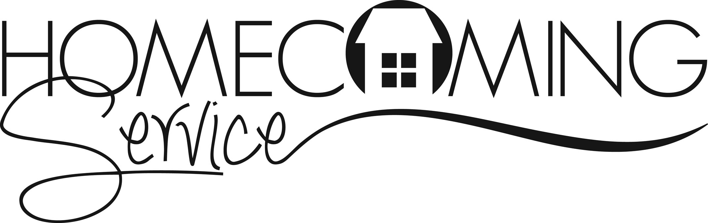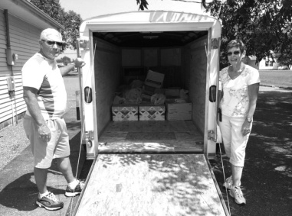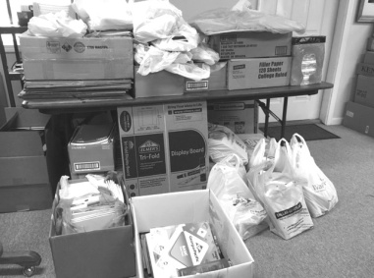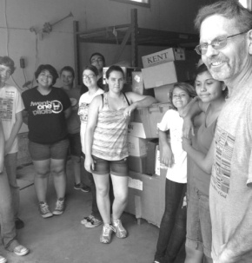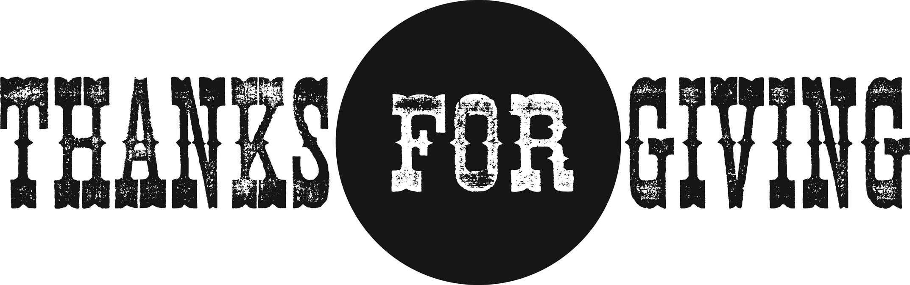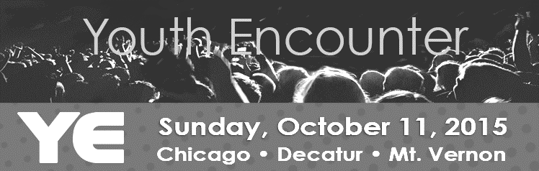

**Disaster Relief Training**

Friday & Saturday, October 9-10

Lake Sallateeska

Details will be in next month’s newsletter.

**Pastor and Family Picnic**

Saturday, September 26th

5:00 p.m. at Vienna Park

If you plan on attending, please bring a dessert.

**Dates: October 22-25**

**Times: Thursday & Friday 6:00-10:00pm**

**Saturday 5:00-10:00pm**

**Sunday 4:00-10:00pm**

**Location: Metropolis 1st Baptist**

**If you are bringing a group, please call the church ahead of time to schedule.**

**Dixon Springs Baptist Church**

**Sunday, September 13th**

**Sunday School: 9:30 a.m.**

**Homecoming service: 10:30 a.m.**

A potluck meal will follow. Entertainment will be by “The Good News”. Everyone is invited!

**School Supplies**

Recycled literature was delivered this past month to Eagles Nest in Butler, Illinois. When we arrived there, a youth group from Elgin, IL helped to unload the material. Many thanks to the churches and individuals who contributed to the donation.

**The Annual Church Profiles were mailed to all clerks or churches in our association. If you did not receive yours, please call our office. The ACP’s are due back to our office by October 6th or as soon as possible after that. If you get yours filled out before Oct. 6, we would appreciate your mailing it in early. We appreciate the time and effort that goes into providing this information!**

**Annual Book of Reports**:

We are asking all Department Heads to please turn in their annual reports by September 28th.

**Please pray for the following church that is currently without a pastor: New Beginnings**

**One-Day Mission Trip to Eagles Nest, Butler, IL**

**Monday, October 5th**

We will be taking a group to sort literature. To reserve a seat on the van, please call our office. We have a twelve passenger limit on the van.

*We would like to thank all of the churches and individuals who have given to the UBA Annual Love Offering! To date, we have received $2,528.00!*

*On behalf of the Baptist Children’s Home, we would like to thank all who attended the annual singing! It was a wonderful evening of inspirational music and $3,060.25 was raised for the children’s home. Thanks to Dixon Springs Baptist and Danny Carter for putting this together.*

**Union Baptist Association Quarterly Meeting**

**Monday, August 31, 7:00 p.m.**

**Vienna 1st Baptist**

**All church Executive Board Members, Associational Council Members, and Pastors are urged to attend.**

Youth Encounter is an evangelistic opportunity for hundreds of students to be led in worship by up and coming Christian artists, while being inspired and challenged by some of the top student ministry speakers in the country. Student leaders should seize this opportunity to attract students in need of Christ, but also being confident that the event will benefit their entire group. Featured this year are: 321 Improv, David Nasser, Jordan and Jessa Anderson, Shuree Rivera, The Great Romance.

The nearest location for Youth Encounter is Logan Street Baptist Church in Mt. Vernon, IL. It will be held on October 11, 2015 from 3:00pm to 10:00pm. The cost is $25 per person.

For more information, as well as registration, please visit the IBSA website at ibsa.org/students. The deadline is October 9th.

**Saturday, September 12th**

**Metropolis Sportsman’s Complex**

**9:00 a.m. – check-in**

**10:00 a.m. – games begin**

**Registration deadline – September 10th**

There is a 16 team limit. To register, please contact Sherri Wright at 618-771-2291 or Terry Mathis at 270-559-3717.

**Christian Activity Center Collection –** Thanks to all who donated school supplies. We would also like to thank Tom & Barb Jones for delivering them to the center!

**7th and 8th Graders**