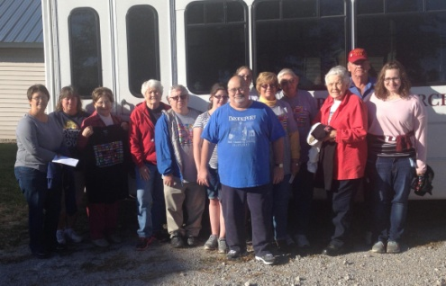

**Association Executive Board**

**Christmas Dinner and Meeting!**

**Date: Monday, December 5, 2016**

**Location: Simpson Baptist Church**

**Times: 6:00 p.m. Meal (meeting to follow)**

**All pastors, board members, council members, including their spouses, are invited to attend.**

**Please RSVP by contacting the UBA Office by December 1st.**

**Association Women on Mission FALL MISSION GATHERING**

Thursday, November 10, 2016

Union Baptist Association Office

11:30---Lunch (Catered)

12:15---Program

Program Leader---Judy Taylor

Dorisville Baptist Church—Harrisburg, IL

*RSVP the UBA Office by **Nov. 4** if you are coming or give the number of your church group coming for the catered meal (Chick-fil-a)

**Also, please bring non-perishable food item(s) for our local food banks to help feed families over the holidays.

**Eagle’s Nest Love Packages**

**One-Day Mission Trip**

**October 24, 2016**

the

UBAconnection

**MONTHLY MISSION PROJECTS**

**OCTOBER: Operation Christmas Child Shoeboxes**. The dates and times for drop-off are Monday – Saturday, November 14th-19th, 2:00-6:00pm and Sunday, November 20th 12:00-2:00pm

**NOVEMBER:**  Christian Activity Center, E. St. Louis – Adopt a Child for Christmas **-**Get paired with the Christmas list of a child and provide wrapped gifts equaling $100 OR you can give a monetary donation of $100 and the center will do the shopping for you. Contact Margaret McCurdy via email: ilslsgrl@yahoo.com or by phone: 217-416-8181, to get paired with a child's wish list. If you would like to give a $100 monetary donation, mail your check to 540 N. 6th St., P.O. Box 2525, East St. Louis, IL, 62201. You may also give online by visiting cacesl.org/christmas. If you are purchasing gifts for the UBA to deliver, please bring them to our office by **Nov. 30th**.

**DECEMBER:** Helping local ministries meet needs for Christmas

**JANUARY:** Donations to local food pantries. Please collect non-perishables and deliver to your local pantry.

**Union Baptist Association Terry Mathis, Director of Missions**

**P.O. Box 29 email:mathisterry2009@hotmail.com**

**Metropolis, IL 62960 Beverly Turner, Admin. Asst.**

**618-524-9738 bevturneruba@gmail.com**

**UBA theme for 2017: “For we cannot keep from**

**speaking about what we have seen and heard” Acts 4:20**

**NOVEMBER & DECEMBER 2016, JANUARY 2017 &NEWSLETTER**

**Union Baptist Association**

**P.O. Box 29**

**Metropolis, IL 62960**

***Return Service Requested***

**Non-Profit Organization**

**U.S. Postage Paid**

**Permit #137**

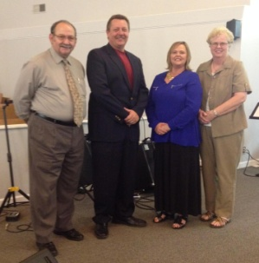

**2017 Union Baptist Association**

**Elected Officers**

**November, December 2016 & January 2017 newsletter**

**Please note that we will not be mailing another newsletter until the end of January. We have included information for November, December and January in this newsletter.**

**Volume 1, #63**

**Frank Forthman, Jr. – Moderator**

**Jerry Jackson – Vice-moderator**

**Linda Mathis – Clerk**

**Karen Faulkner – Assistant Clerk**

***UBA Theme for 2017 …***

**“Can’t Help It”**

**Acts 4:20**

**“We cannot** ***help speaking***

**about what**

**we have** ***seen*****and** ***heard***”