

**Immanuel Baptist is once again the drop-off point for Operation Christmas Child shoeboxes. The times are**

**Nov. 18th-23rd, 2:00-6:00pm & Nov. 24th-12:00-2:00pm**

**NOVEMBER MISSION ACTION:**

**Christian Activity Center, E. St. Louis**

**If you would like to provide Christmas gifts for a child, please call the center.**

**Please bring gifts to the UBA Office no later than Monday, December 2nd.**

**Leadership Team: Toby and Judy Davis**

We are very thankful that Weaver Creek Baptist Church has once again begun supporting the Union Baptist Association. We are thankful to the Lord for our partnership together in reaching our community and the world with the good news of Jesus Christ.

Weaver Creek Baptist is currently in the process of a new building program, but they have a great local ministry by which the church helps many people. I have asked their pastor, Bro. Shawn Vandergriff, to write the following article about their ministry.

***Coming Events!***

**ADULTS ON MISSION**

**WORLD DAY OF PRAYER**

**November 4, 2013, 10:00 a.m.**

**UBA OFFICE**

**All men and women are invited!**

**Please bring a pot of soup or some sandwiches.**

**BOOK SIGNING!**

Paula McGinnis, a local resident of the Metropolis area, is a new author of a devotional book written by inspirations from God, “The Road of Life, God’s Guidance on Life’s Journey”. She will be having a community book signing event scheduled on November 10th, 2013 from 12:00-5:00pm at the Metropolis Community Center. All proceeds from this book signing event will go to the bridge ministries in Massac County. Paula’s 67 paintings of the Massac County churches will be on display at this book signing event for the public to view. She would like to invite the community to attend so that she can share the inspirations that God has given her.

***Please pray for our traveling missionaries:***

***Nov. 9 – 16 –Haiti – Amy Land, from Brookport First, will be traveling with a church group from Paducah to work in orphanages. The UBA is helping to sponsor her out of the Love Offering!***

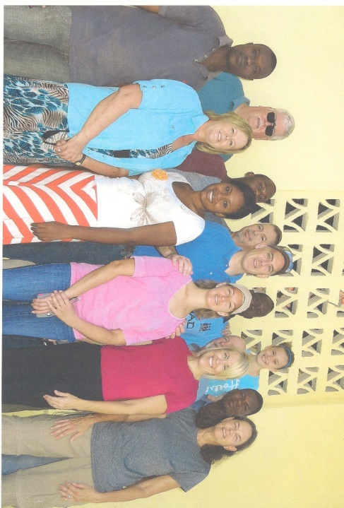[](http://www.churchart.com/Subscriber/ViewImages.aspx?keywords=&entry_date=1/1/0001&image_type=,cl,ca,ph,ch,pp,bc&topic_id=372&image_source_id=&page=1#no)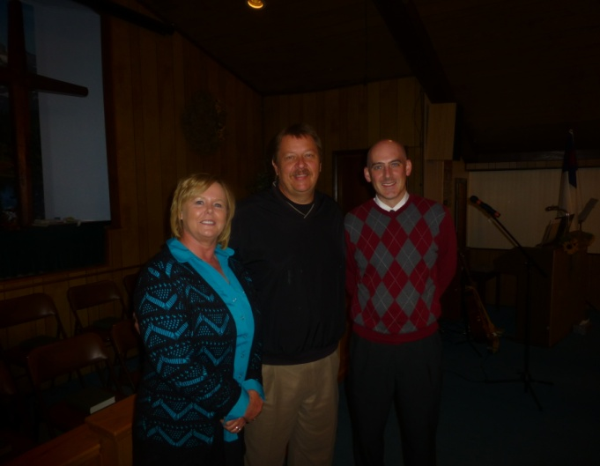

**AT THE RIVER MINISTRIES** will be providing a community wide free meal on November 25th, 5:00 p.m. at Life Church Eastland. This will be in addition to Life Church’s annual Thanksgiving meal. If you or your church would like to contribute a frozen turkey, please call Dan Haun at 618-638-6901. Please help spread the word to those in our community about this free meal.

**Haiti Mission Team**

**Haiti Mission Trip a Success!**

Those who went: Terry & Linda Mathis (Met. 1st), Ben & Eren Hottel(Hillerman), Terry & Tam Foster(Met. 1st), Jackie & Emma Lange(Met. 1st)

For 5 hours each day, the men taught Bible Study or Leadership to twenty-five pastors, deacons and church leaders.

The ladies taught 8 to 10 teenage girls in the afternoon and then held a Bible Club with games for about forty kids.

Two of the ladies spent 4 days at an orphanage.

Thanks for all the prayers and thoughts while on this trip.

We at Weaver Creek Baptist Church officially launched Get Involved Ministry Community Outreach, in August 2012. This ministry is aimed at reaching out to those individuals and families in the community who need help the most. Helping people and the community is something Weaver Creek has always done, but we have modified things to be as effective as they can be. The heart of this ministry was born out of **John 13:35** "By this shall all men know that ye are my disciples, if ye have love one to another." and **Matthew 25:31-40.** With that passage in mind we are out to share the Gospel of Christ as we offer to help our brothers and sisters in the county of Massac. Each person we help meets with us and we share the Gospel, offer counseling, and then we help meet a need in their life. The list of services we provide is as follows

1. Food- we have a food pantry where we set up the families in need with items to last between 1-2 weeks.

2. Clothing- we have clothing for families available.

3. Household items- from furniture to hygiene products. We provide these for families in need.

4. Assistance- this usually is in the form of bill pay, gas, ECT. We have some funds available for residents per year.

Lastly we want to invite all Churches to join us in this effort You can get involved by praying for this outreach, donating food, clothing, household items (beds, dressers, dishes, etx.) or by giving financial gifts. Also, we invite the other churches to establish outreach centers as well we would love to share any and all information needed to start one up. If you know of anyone in need please call us at (618) 309-2335.

God Loves You,

Pastor Shawn

**IS YOUR CHURCH ON MISSION?**

We would love to hear about your church’s mission trip or mission work you are doing. We want to share what God is doing through Union Baptist Association churches. Just call, email (bevturner@metrouba.com), or drop by with the information so that we can print it in future issues of our newsletter.

**IBSA PASTOR’S CONFERENCE & ANNUAL MEETING**

**Pastor Conference**: Begins Nov. 12 at 1:00pm

Concludes Nov. 13 at 11:15am

**Speakers:**

Eric Mason – author of “Manhood Restored”

Chuck Kelley – President of New Orleans Baptist Seminary

Micah Fries – Vice-president of LifeWay Research

Bobby Boyles – Church Planter Consultant

Jerry Cain – President Emeritus of Judson University

Jay Stother – Teaching Pastor of The Church of Staton Hill, TN

**Annual Meeting**: Begins Nov. 13 at 1:30pm

Concludes Nov. 14 at 11:30am

You can register online by Nov. 4 by contacting Carole Doom at caroledoom@ibsa.org or call 217-391-3113.

**UBA Executive Board**

**Christmas Dinner**

**Monday, December 2, 2013**

**6:00 p.m. at Metropolis First Baptist**

***All Executive Board Members, Pastors, and Council Members, along with their spouses, are invited!***

***Please RSVP by calling the UBA Office by November 27th.***

**Newly Elected Officers of the UBA**

**Highlights of the 146th Annual Meeting of the Union Baptist Association**

The 146th Annual Meeting took place this past October 21st at Joppa Missionary Baptist Church. Both sessions were well attended with 18 of our 20 churches represented. Our theme this year is “Compassion – Moved to Move” from Matthew 9:35-38.

Pat Pajak, the Executive Director of Church Strengthening from the I.B.S.A., taught our Bible Study for both sessions. The Annual Message was given by Ben Hottel, Pastor of Hillerman Baptist and the Mission Message by Terry Mathis, our Director of Missions. All three spoke on the theme and its passage of scripture.

All of the reports were given by the various department directors in the association, along with greetings from the Baptist Children’s Home, Mid-Continent University and the I.B.S.A. An Acts 1:8 Celebration was given by several people speaking about mission work they were involved with locally and around the world. We were very honored to have as a guest Bro. Ben Yeanay of Africa.

During the Business Session, there was only one motion from the floor and it passed. It was to raise the Kid’s “Camp Mac” fee from $45 to $55 per child starting next year. This will help to offset camp expenses. Other business was from committees and the appointment of the moderator.

Newly elected officers for the 2013-2014 association year are:

Ben Hottel – Moderator

Frank Forthman, Jr. – Vice-moderator

Linda Mathis - Clerk