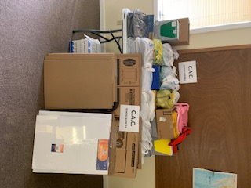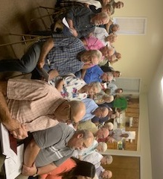

**Shoebox Collection for Operation Christmas Child**

**Once again, Immanuel Baptist ( 1119 Market St., Metropolis) will be the drop-off location. Times and dates are the following:**

**Mon., Nov. 18 – Sat., Nov. 23: 2:00 PM - 6:00 PM**

**Sun., Nov. 24: 12:00 PM - 2:00 PM**

**Mon, Nov. 25: 9:00 AM - 11:00 AM**

**July Mission Project:**

**School Supplies for Christian Activity Center**

**A big thanks to all who donated!**

**The August Executive board meeting was the first ever held at the UBA Office.**

**The Week of Prayer for the Lottie Moon Christmas Offering is December 1st– 8th. Please promote this in your church.**

**Monday, December 2, 2019**

**Meal at 6:00PM, Meeting at 7:00PM**

**at New Hope Baptist Church**

**All Executive Board Members, along with their spouses are invited! Please RSVP by November 26th if you plan on attending!**

***This newsletter contains information for November, December and January. The next newsletter will be sent out the end of January.***

**Volume 82**

**The UBA Connection**

**UBA theme for 2020: Matthew 5:13-16 – “...*let your light shine before others...”***

**Union Baptist Association**

**P.O. Box 29**

**Metropolis, IL 62960**

***Return Service Requested***

**November, December 2019 and January 2020 NEWSLETTER**

**Non-Profit Organization**

**U.S. Postage Paid**

**Permit #137**

**UBA MONTHLY MISSION PROJECTS**

**NOVEMBER:** Collection for Salt & Light Ministries (clothing ministry at New Beginnings Baptist). We are collecting the following items: Scented Drawstring kitchen trash bags, In-wash scent booster beads, Clorox wipes, and gallon-size Ziploc bags. Please bring items to our office by Thursday, December 5th.

Also in November, Operation Christmas Child

**DECEMBER:** Local Ministries – Meeting needs for Christmas. Each church is asked to pick a local ministry to help out.

**JANUARY:** Collection of nonperishable food items for local food pantries. COPE, Karnak, Vienna, Joppa, Weaver Creek

**Union Baptist Association Terry Mathis, Director of Missions**

**P.O. Box 29 (716 E. 12th) email:terrymathis2019@outlook.com**

**Metropolis, IL 62960 Beverly Turner, Admin. Asst.**

**618-524-9738 bevturneruba@gmail.com**