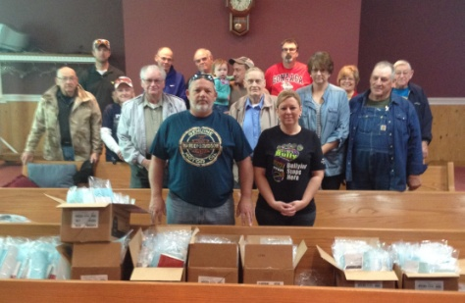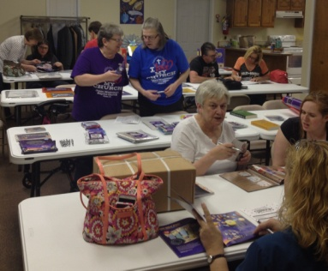

We had outstanding participation in our Association VBS Material Preview. We had 11 churches to order their VBS material through the association. Thanks for all who came and ordered!

To the right is a photo of those who served on Saturday, April 8 at Karnak First for Operation Saturation. We hung some 310 door hangers which included a Bible and church information around the Karnak area.

**ASSOCIATIONAL VBS DATES:**

**Brookport 1st – June 4-8, 6:00-8:30pm**

**New Hope – June 5-9, 6:00-8:00pm**

**Seven Mile – June 6-10, 6:00-8:00pm**

**Metropolis 1st – June 19-23, 9:00am-noon**

**Eastland Life – June 26-30, 9:30am-12:30pm**

**Vienna 1st – July 8, all day 9:00am-4:00pm**

**Mt. Zion Missionary– July 16-21, 6:30-8:30pm**

**Hillerman Missionary– July 16-20, 6:00-8:30pm**

**Karnak 1st- July 16-20, 6:00-8:00pm**

**Dixon Springs – July 24-28, 6:00-8:30pm**

**County Line – August 5, all day 9:00am-3:00pm**

**Joppa Missionary– August 6-10, 5:30-8:00pm**

The UBA Women on Mission purchased a Bilingual Bible for an International student from Japan. It was given to her before she returned home in April.

**CAMP MAC 2017!**

**Dates: July 9-15, Theme: “Priceless”, Eph. 2:10**

Registration packages will be available at your church beginning May 21st. Ask your pastor for a form or stop by the UBA Office to pick one up. ***The deadline to register is June 30th.***

**UBA Love Offering Sunday is July 9th (or any Sunday in July)**

**This annual offering goes to help individuals and groups to go on mission trips associated with the UBA churches. If your church doesn’t participate in the offering, but you would like to give, just stop by our office or mail your offering to us. Materials for the offering will be mailed to churches soon.**

**MONTHLY MISSION PROJECTS**

**MAY** – Collection for Guardian Family Services. Please collect at your church and deliver to GFS, 117 W. 10th, Metropolis. Needed items are:

**Socks** of all sizes; **Underwear** of all sizes and styles; **Deodorant**; **Hairbrushes** for all ages; **Disposable razors**; **Shave cream**; **Tampons**; **13-gallon trash bags**.

Mother’s Day-Father’s Day: Hope Unlimited Baby Bottles. Pick up a bottle at your church and fill it with change or bills. For more information, call Hope Unlimited at 524-5730.

**JUNE** –Collection of non-perishable items for Camp Mac. In May, each church will be mailed a list of items that are needed. This collection helps offset the cost of food for camp. Please drop items off at our office by June 29th.

Also in June, we collect literature to be recycled at Eagle’s Nest.

**JULY** – School supply collection for Christian Activity Center

**Union Baptist Association Terry Mathis, Director of Missions**

**P.O. Box 29 email:mathisterry2009@hotmail.com**

**Metropolis, IL 62960 Beverly Turner, Admin. Asst.**

**618-524-9738 bevturneruba@gmail.com**

**UBA theme for 2017: “For we cannot keep from**

**speaking about what we have seen and heard” Acts 4:20**

**MAY & JUNE, 2017 NEWSLETTER**

**Union Baptist Association**

**P.O. Box 29**

**Metropolis, IL 62960**

***Return Service Requested***

**Non-Profit Organization**

**U.S. Postage Paid**

**Permit #137**

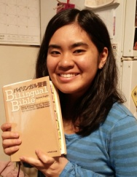

**Volume 1, #67**

the

UBAconnection

***This newsletter contains information for both May and June.***

***The next newsletter will be sent July 1st.***