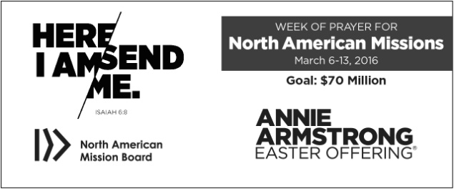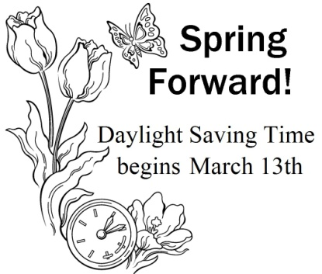

Week of Prayer March 6-13: The Annie Armstrong Easter Offering is the primary funding channel for the North American Mission Board’s Send North America strategy. One hundred percent of the gifts given to the Annie Armstrong offering is used to support Southern Baptist missionaries serving in the U.S. and Canada.

**BIRTHDAYS**

March 4 – Cliff Easter, Family Pastor, Metropolis 1st

March 5 – Grace Buchanan, Pastor’s wife, Metropolis 1st

March 12 – Dean West, Pastor of Karnak 1st

March 25 – John Windings, Music Pastor, Metropolis 1st

**WEDDING ANNIVERSARY**

March 19 - John & Jenny Windings, Metropolis 1st

**CHURCH ANNIVERSARY**

Glenn Coram, Immanuel, 2011

**UBA VOLLEYBALL TOURNAMENT SCHEDULE:**

“C” Division – Friday, March 4 @ Simpson

Beginning at 5:00 p.m.

“A” Division – Saturday, March 5 @ Joppa

Beginning at 8:30 a.m.

“B” Division – Friday, March 11 @ Brookport

Beginning at 6:00 p.m. (4 games)

Remaining Games – Saturday, March 12 @ Brookport

Beginning at 9:00 a.m.

**Monday, March 14**

**7:00-8:30am**

**Jumbo’s in Vienna**

**MEDICAL MISSION CONFERENCE:**

**March 19, 2016, 9am-4pm**

The International Mission Board and Baptist Global Response will be holding a Medical Mission Conference at Heartland Worship Center in Paducah. There is a $10.00 charge to cover the cost of materials and a noon lunch. You can register by calling 270-534-1400 or by going online to heartlandworship.com

**Event Description**

• Learn about new effective health strategies.

• Become better equipped for short-term missions.

• Hear about Southern Baptist Medical Missions that cover the globe.

• Discover service opportunities.

• Network with other like-minded health care professionals

Who can come? All health care personnel and church leaders with a heart for medical missions.

**UBA Executive Board and Council Meetings**

Monday, March 7, 2016 at New Beginnings

6:00pm – Council Meeting

7:00pm – Executive Board Meeting

**Please continue to pray for the following church that is currently without a pastor: New Beginnings**

**Next UBA Church Leadership Renewal Training**

Date: Monday, March 21, 2016

Times: 6:00 p.m. meal

6:45 p.m. training

7:45 p.m. question/answer session

Speaker: Bobby Pell, Pastor of Northwood Community Church in Evansville, IN

Subject: “Casting Vision to Members”

We encourage and invite all pastors and church leaders to attend this valuable training. Please RSVP the UBA office by the 17th.

**Church Treasurer’s Training**

**Thursday, March 10th**

**6:00 p.m. at the UBA Office**

Anyone who handles finances for their church will benefit from this training. A meal will be served at 6:00. Please RSVP to the UBA Office by Monday, March 7th.

***Church Contributions for Budget***

***(rec’d & deposited in January 2016)***

Brookport First $ 0.00

County Line $ 0.00

Cypress First $ 50.00

Dixon Springs $ 176.00

Hillerman Missionary $ 600.05

Immanuel $ 268.68

Joppa Missionary $ 820.07

Karnak First $ 894.17

Life Church Eastland $ 200.00

Metropolis First $ 2,099.05

Mt. Zion $ 251.12

New Beginnings $ 0.00

New Hope $ 2,424.25

New Salem $ 40.00

Oak Grove $ 40.60

Revelation Road $ 24.00

Seven Mile $ 0.00

Simpson $ 208.00

Vienna First $ 433.33

Waldo $ 466.67

Weaver Creek $ 50.00