***Please pray for our travelling missionaries:***

JAMAICA: Jan. 19-26 –David Wright, Kevin Miller, and Duane McGinnis

PERU: Feb. 8-16 – Four from Eastland Baptist plus 3 other missionaries

HAITI: March 23-30 & March 30-April 6 – Two teams from Metropolis First

INDIA: March 2013 - Nelda Smothers

**Winter Bible Study for 2013**

**Luke’s Account of the Passion Week**

Bro. Terry has just a few dates remaining open in March to teach this in your church. The time frame is four one-hour sessions.

**The Beast Feast 2013**

**For Outdoor Sportsmen**

**Saturday, March 16, 2013**

**Joppa Missionary Baptist**

**Meal @ 6:00 p.m., Program @ 7:00**

**Tim Burton—Guest Speaker**

**Men, Women and Kids welcome!**

***There will be many other surprises on this evening, so use this as an outreach to invite your sporting buddies to! They will meet others and be fed both physically and spiritually.***

IRON SHARPENS IRON

Conference for Men

Saturday, February 23rd at O’Fallon Baptist Church

You need to be planning and organizing a group of men to go. You can order your promotional packet today from www.ironsharpensiron.net or call 217-622-4069.

**CHILDREN’S MINISTRY DAY**

**Saturday, March 16, 2013**

**Park Ave. Church in Mt. Vernon**

This day is an amazing mission experience for girls and boys in grades 1-6. Children and leaders choose a hands-on ministry project that makes community missions come alive. The cost is $15/person. Online registration begins January 14 or you can contact Barb Troeger at 217-391-3138

**MINISTER’S WIVES RETREAT**

**Friday-Saturday, March 8-9**

**Litchfield First Baptist**

This is a time of renewal and fellowship for wives of pastors. Cost is $45/person which includes conference fee, hotel and meals. Contact Alice Davis at alidavis@mchsi.com

***Please let us know if you have an event that you would like to have promoted in our newsletter, on our website, or on our facebook page!***



March 9-16, 2013

La Place, LA

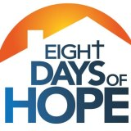

Eight Days of Hope is a faith based organization that focuses on one area a year to help restore and rebuild damaged homes. This year Eight Days of Hope Project X is partnering with Hurricane Isaac victims to help rebuild in LaPlace, LA on March 9-16th.

The last date to register online is February 24, 2013. To register or for more information, please email 8daysofhope@gmail.com or call 662-844-6934. The web address is eightdaysofhope.com Our local contact is Steve Russell of Waldo Baptist. Steve has participated in this event the past few years. His number is 270-217-4846.

**IBSA Workshops:**

**Technical Ministries Workshop**

**Saturday, March 2, 2013**

**IBSA Building, Springfield, IL**

Learn basic sound and video technology and how to tweak them for maximum use in your church. To register and get times, call 217-391-3126 or email debbiemuller@ibsa.org

**Grant Writing Workshop**

**“The Artful Askers Workshop”**

**Two Dates/Two Locations, 9:00 a.m.-4:00 p.m.**

Friday, March 1st at Crosspoint Baptist in Edwardsville

Saturday, March 2nd at East Central Baptist Assoc. in Mahomet, IL

This workshop will equip you to discover resources for your ministry. Cost is $49/person. Email debbiemuller@ibsa.org to register.

**Evangelistic Leaders Workshop**

Tuesday, March 12th, Marion 2nd Baptist, 10:00-2:00

Learn the best practices, strategies, and processes for reaching your church community. This free workshop includes lunch. Registration required. Contact barbarahalleman@ibsa.org

**From Larry Fugate,**

**UBA Sunday school director:**

**How to make it easy to attend and join Sunday School**

**How many never come because there were no greeters to help them find out what class to attend? How many never come because they arrived after Sunday school started and all the greeters had gone to class?**

Ouch! This is doubly painful because guests were ready to attend. They showed up planning to go to a class or classes. But they didn’t know where to go. They didn’t have anyone to help them. If you invite someone to Sunday school, meet them at a door so they won’t have to find their way through your facility—even if it is a small one. Put a face on your first impression. Don’t tell people where to go; take them there! That means ideally your Sunday School would have at least two greeters at all strategic entrances. If you have a welcome center door, that would encourage guests to enter one door. Encourage your greeters to stay late. Make sure they are friendly. Choose people who represent the age group you want to reach.

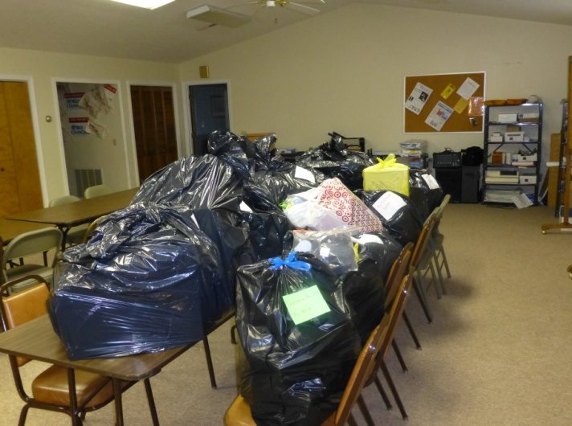

**THE NOVEMBER MISSION PROJECT WAS COLLECTING GIFTS FOR THE CHRISTIAN ACTIVITY CENTER IN E. ST. LOUIS. THESE ARE THE BAGS OF GIFTS THAT WERE DONATED BY CHURCHES FROM OUR ASSOCIATION!**

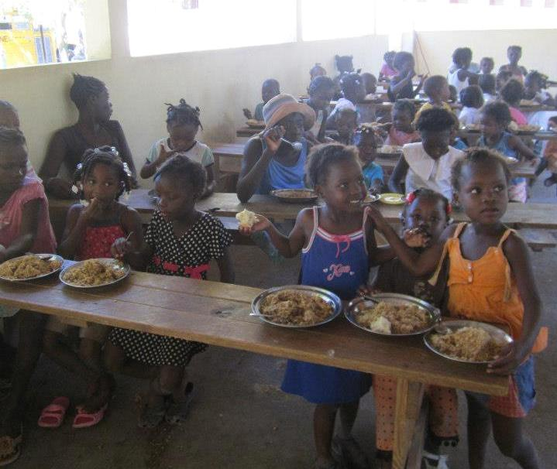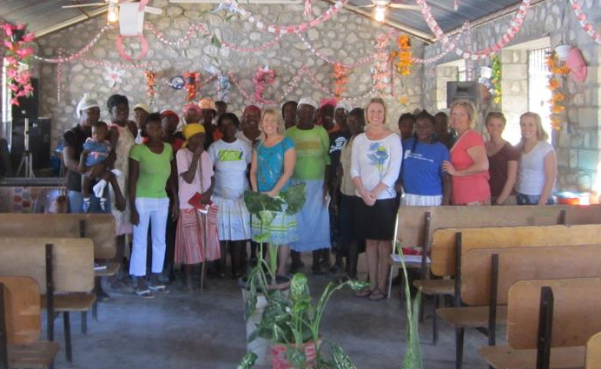

***Scenes from the recent Metropolis 1st trip to Haiti!***

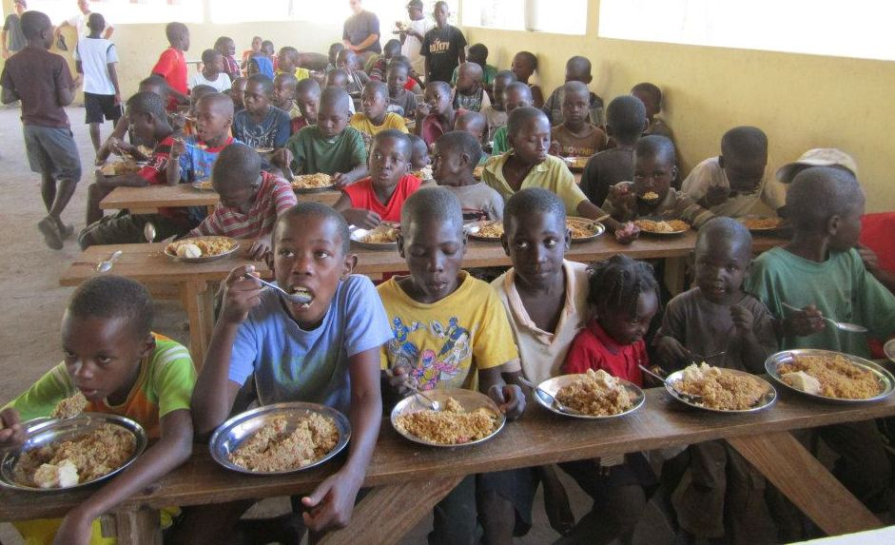

**The Week of Prayer for North American Missions is March 3-10.**

**Churches, please be planning your goals for this offering. The national goal is $70,000,000!**



**2013 ANNIE ARMSTRONG EASTER OFFERING**

**ACTS 8:26-31**

**Looking for a Mission Trip for your church, mission group, Sunday School class, etc.? Contact the UBA Office. We have connections with some 20 different mission projects in connection with the IBSA. These trips are within the state, national, as well as international. Contact us early in the new year as many of these mission projects have deadlines for reservations.**

**UBA FEBRUARY MISSION PROJECT:**

**Hope House – Cancer patient Housing in Nashville. They are in need of the following: Toilet paper, paper towels, disposable plates, disposable cups (hot & cold), dishwashing detergent tablets, hand sanitizer, decaf coffee, trial size toiletries (they are very low on these). PLEASE BRING ITEMS TO THE UBA OFFICE BY FEBRUARY 28TH.**

**Team Leader: Linda Mathis**



**UPDATE FROM MEXICO:**