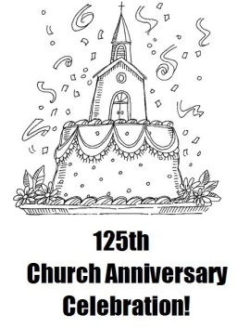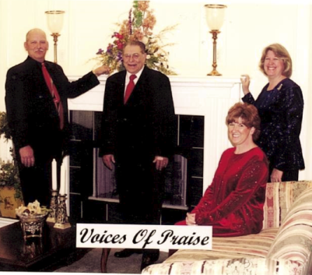

**Brookport First Baptist Church**

**125th Anniversary Celebration**

**Speaker: Greg Giltner, Former Pastor**

**Special Music: Darlene Landis**

**September 11, 9:30 a.m. to 2:00 p.m.**

**Stay and fellowship with a meal and games after the service.**

**VBS Reports – Please remember to turn in your VBS reports to our office. We will forward them to LifeWay.**

**Saturday, August 20th**

**6:00 p.m. at the UBA Office**

**This is for all Music Leaders, as well as musicians.**

**Please call or email in your reservations by August 17th!**

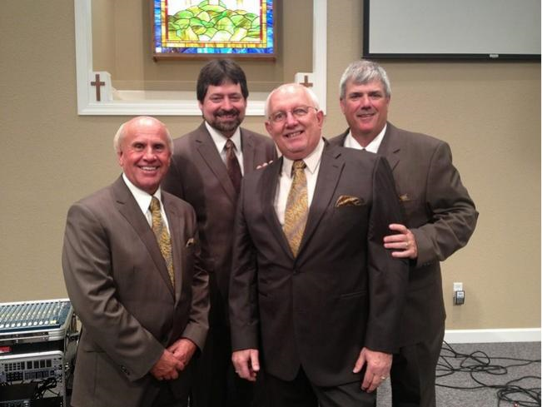

**Dixon Springs Baptist Church**

**East of Vienna on State Route 146**

**Saturday, August 27th, 7:00 p.m.**

**All proceeds go directly to the BCHFS in Carmi, Illinois**

**Baptist Children’s Home & Family Services**

**13th Annual Benefit Singing**

***FEATURING***

**Italy Group**

**Haiti Group**

**Volume 1, #60**

**MONTHLY MISSION PROJECTS**

**AUGUST:** Local Crisis Intervention. Each church is asked to pick a crisis center in their community to serve in some way. This could be police, firefighters, EMT’s, abuse centers, etc.

Baptist Childrens Home Annual Singing

**SEPTEMBER:** Baptist Childrens Home Fall Festival. We are asking each church to supply items for the Silent Auction at the Fall Festival. These can be homemade craft items, purchased items or quilts for the quilt auction. The deadline, for bringing these items to our office, will be listed in next month’s newsletter.

**Union Baptist Association Terry Mathis, Director of Missions**

**P.O. Box 29 email:mathisterry2009@hotmail.com**

**Metropolis, IL 62960 Beverly Turner, Admin. Asst.**

**618-524-9738 bevturneruba@gmail.com**

**UBA theme for 2016: “Disciple- Be One/Make One”**

**AUGUST 2016 NEWSLETTER**

**Union Baptist Association**

**P.O. Box 29**

**Metropolis, IL 62960**

***Return Service Requested***

**Non-Profit Organization**

**U.S. Postage Paid**

**Permit #137**

**AUGUST PASTOR & WIFE BIRTHDAYS**

August 10 – Gary O’Neal, Cypress 1st

August 17 – David Wright, Joppa Missionary

August 19 – Kamie York, Waldo Missionary

August 22 – Carol Siere, Brookport 1st

**AUGUST PASTOR & WIFE ANNIVERSARIES**

August 6 – Dean & Donna West, Karnak 1st

August 24 – David & Karen Faulkner, County Line

**AUGUST PASTOR CHURCH ANNIVERSARIES**

1998 – Gary O’Neal, Cypress

2007 – Joe Buchanan, Metropolis 1st

2011 – Jim Wilson, Oak Grove

2014 – Stephen Williams, Simpson