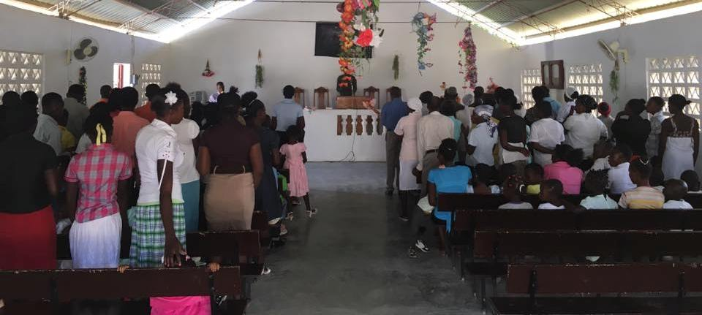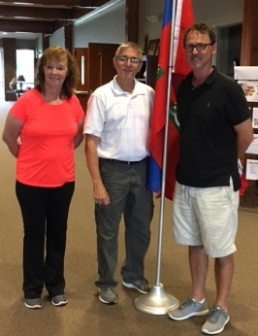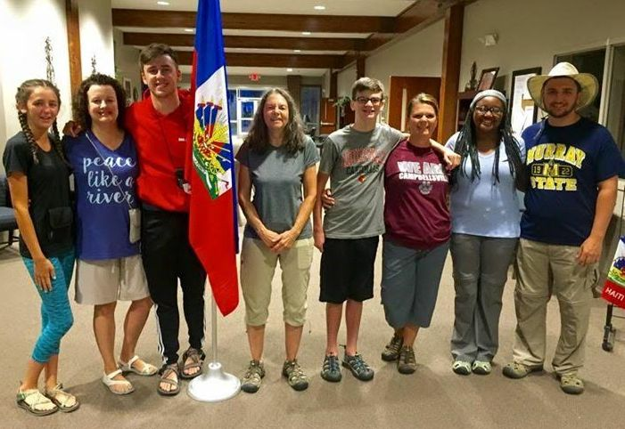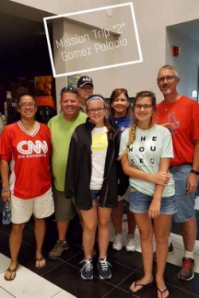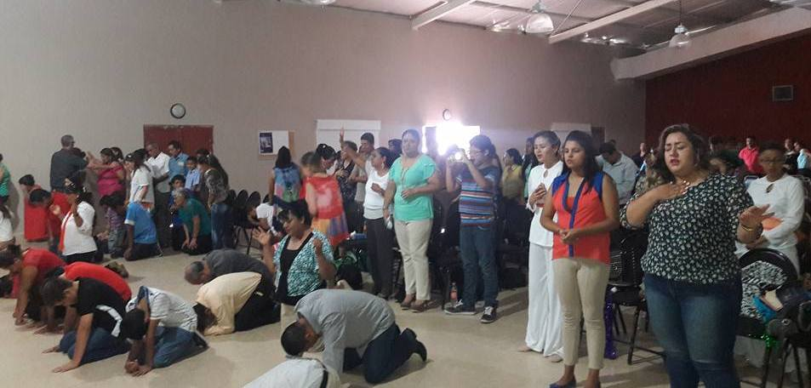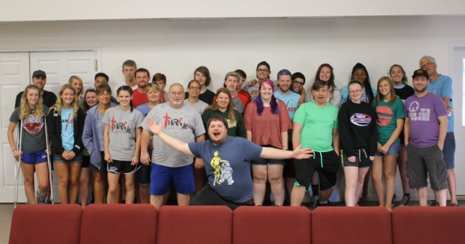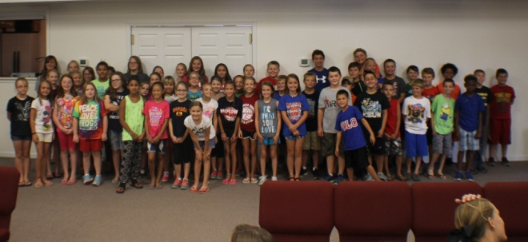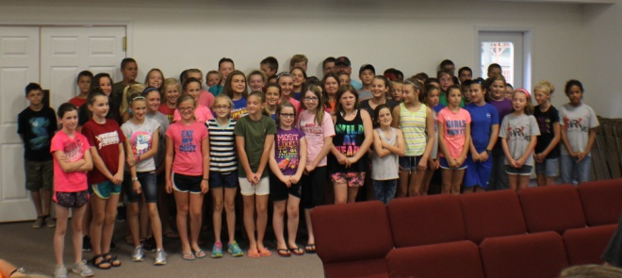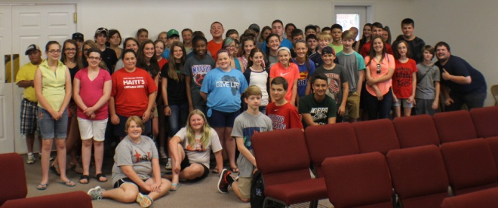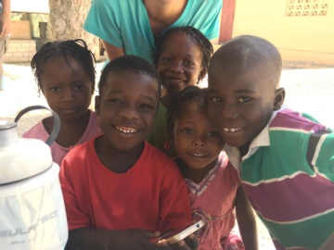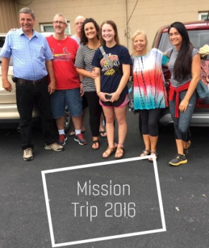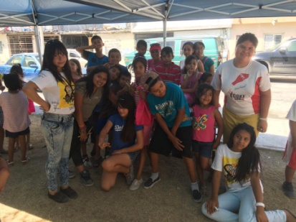

**2016 NATIONAL SUNDAY SCHOOL DIRECTOR SEMINAR**

**Sept. 10, 2016 at Marion 2nd Baptist, Marion, IL**

**8:30 a.m.-3:30 p.m., $39 per person (includes lunch)**

**We hope each church will send their Sunday School Director to this seminar. You may register by calling 800-254-2022 or by visiting lifeway.com/nssds.**

**ATTENTION CLERKS/SECRETARIES - Annual Church Profiles**

The ACP’s were mailed last week to each church in our association. Please take the time to fill these out and return them to our office no later than Thursday, October 6th. This information is very important to our office for record keeping as well as putting together our annual reports and directory.

Facts of the ACP:

* The IBSA, UBA, along with national Southern Baptist entities, analyze ACP information in order to develop future strategies and resources.
* The information you submit is secure, with limited access given only to authorized Southern Baptist entities, such as our association.
* Churches can request multiple years of data through the IBSA for their own analysis. IBSA can provide your church a summary of its historical data whenever you request it.
* Submitting your church’s ACP each year is required in order for your church to be a cooperating IBSA church and to receive the benefits that come from that affiliation.

***Upcoming Association Meetings***

**Association Nominating Committee:**

***Thursday, August 11th, 7:00pm, UBA Office***

**Association Council Strategy:**

***Thursday, August 18th, 6:00pm, UBA Office***

**Association Budget Committee:**

***Thursday, August 25th, 7:00pm, UBA Office***

**Association Quarterly Executive Board:**

***Monday, August 29th, 7:00pm, Weaver Creek***

**Coming in October – Metropolis 1st will be holding a Judgment House again this year!**

**ASSOCIATION BUILDING PROJECT – Date & Time Change**

Bro. Charles Blair has asked for help with the new West Kentucky Baptist Association building in Clinton, KY. We will be hanging sheetrock. No experience needed – just a willing spirit to serve. We have set the dates for August 15-19. We will leave the UBA Office at 6:30 a.m. each morning and will be returning at 3:30 p.m. each afternoon. Please call the UBA Office to reserve your spot and let us know which day(s) you can go.

**Gomez Palacio Mexico Trip**

**Eastland**

**Haiti Medical**

**Metropolis First**

**Grades 7 & 8**

**Counselors & Jr. Counselors**

**Grades 3 & 4**

**Grades 5 & 6**

**Camp Mac 2016-"Flawless"**

Camp Mac this year was one of the greatest! We had a record number of kids and some of the greatest volunteers. As we focused on the theme of "Flawless", using II Corinthian 5:17 as our theme verse, the kids saw how Christ, through the cross, could make them flawless from their sins. As a result, 7 kids accepted Christ as their Savior, along with several rededications. Also, one answered the call to missions, plus many, many, many more came forward to pray. What a spiritual week it was in the lives of the kids and workers at camp! Thanks to all who gave, went and prayed for all of us!

**RECENT MISSION TRIPS**

**Haiti Medical trip**

**Metropolis First**

**Gomez Palacio Mexico Trip**

**Eastland**

**Haiti Trip**

**Metropolis First**

**Monterrey Mexico Trip**

**Eastland, New Hope, Simpson**