

**Association Music Leaders Banquet**

**Saturday, August 15, 2015**

**6:00 p.m. at the UBA Office**

**This banquet is for all music leaders, plus instrumentalists.**

**Please register by calling the UBA Office by Wednesday, August 12th.**

**AUGUST MISSION ACTION:**

Local Crisis Intervention – Each church is being asked to serve the police, firefighters, EMT’s, or other ministries in their community.

Annual Singing for the Baptist Children’s Home

Leadership: Faye Bowman

**SEPTEMBER MISSION ACTION:**

Baptist Children’s Home Fall Festival-September 19th.

We are asking each church to supply items for the Silent Auction at the Fall Festival. These can be homemade craft items, purchased items or quilts for the quilt auction. The deadline, for bringing these items to our office, will be listed in next month’s newsletter.

Camp Mac 2015!

Theme: “Thrive” John 10:10

**A thief comes only to steal and to kill and to destroy. I have come so that they may have life and have it in abundance.**

**We wanted to share with you a little of what goes on at Camp Mac! The most exciting news from camp this year is that there were salvations in every group, with a total of fifteen young people accepting the Lord!**

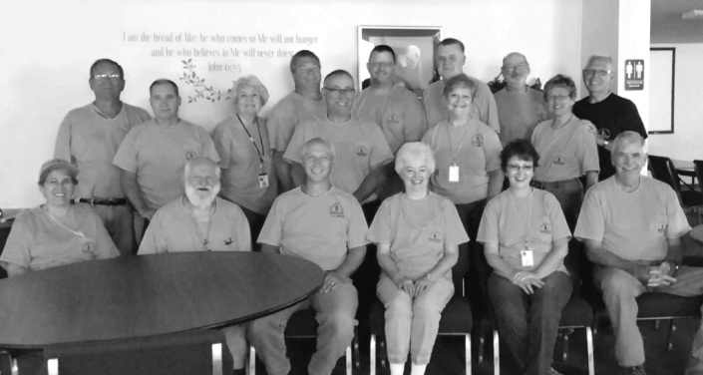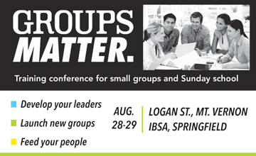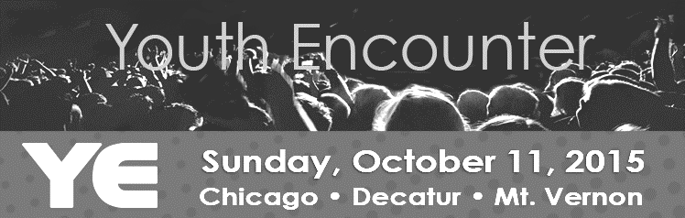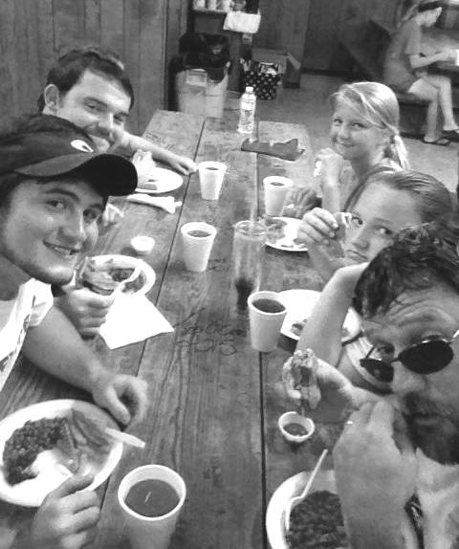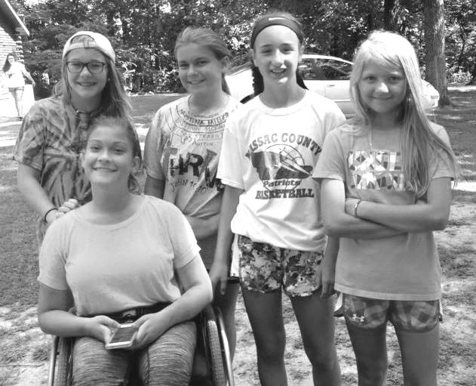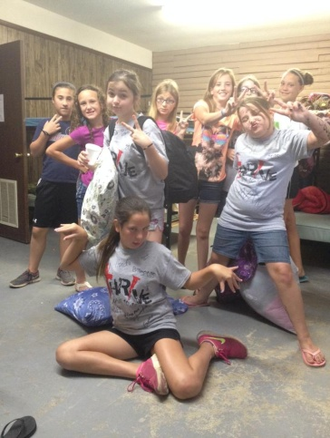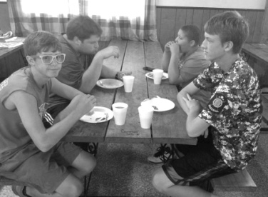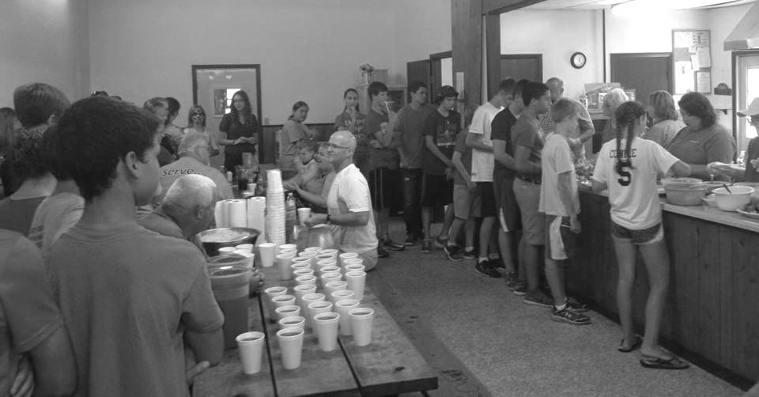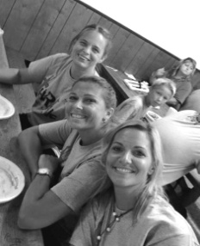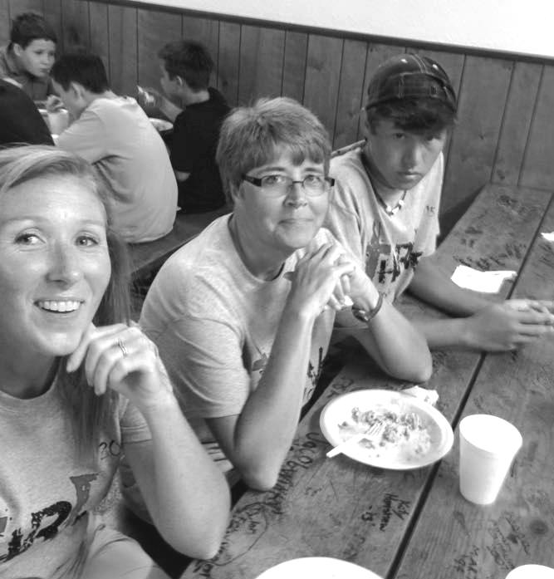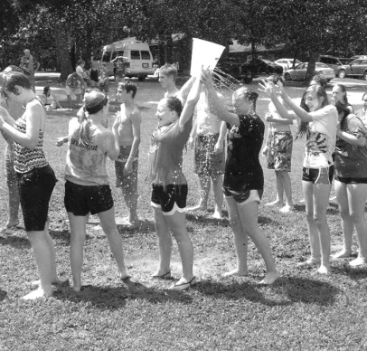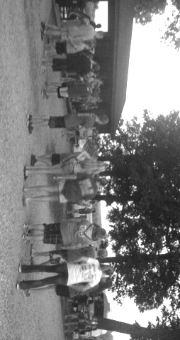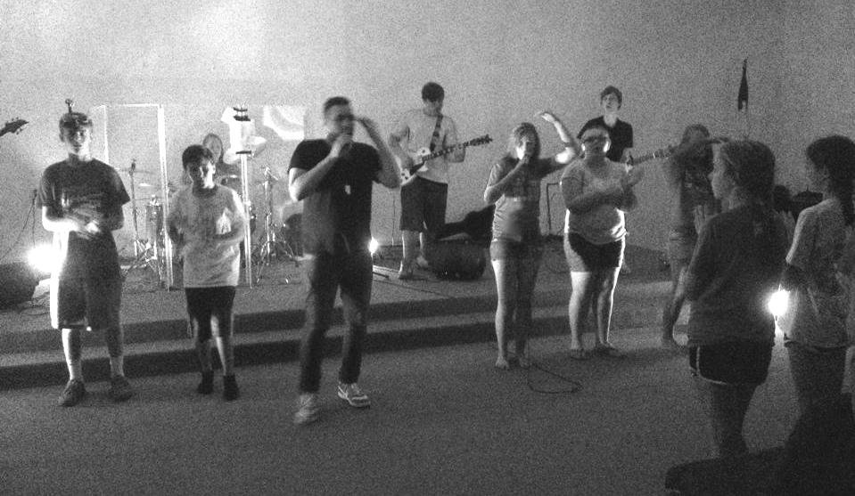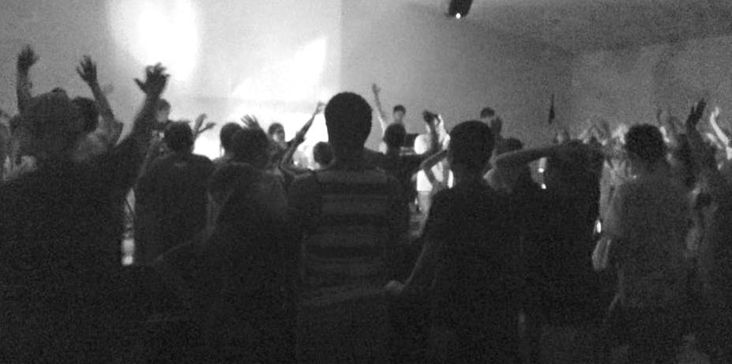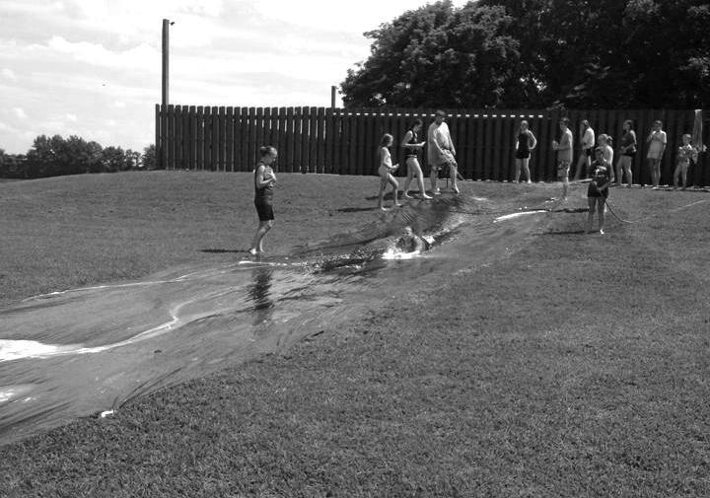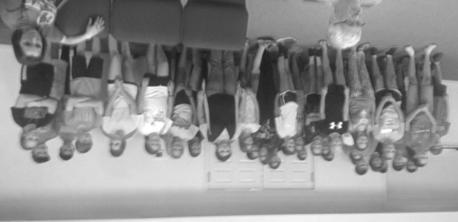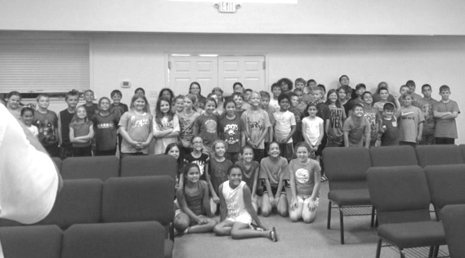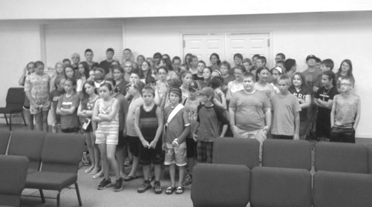

**Association Sunday School Training**

**Saturday, August 22, 2015**

**10:00am-Noon at the UBA Office**

**Coming in October – Metropolis 1st will be holding a Judgment House this year!**

**June 15-24: The Illinois Disaster Relief Teams assisted with Mud-Outs following the flooding in Greeley and Denver, Colorado. Nelda Smothers, from Metropolis 1st, served as Chaplain.**

**Union Baptist Association Quarterly Meeting**

**Monday, August 31, 7:00 p.m.**

**Vienna 1st Baptist**

**All church Executive Board Members, Associational Council Members, and Pastors are urged to attend.**

**FOOD PANTRY NEEDS: With the kids being out of school for the summer, many families are feeling the strain on their food budgets. If you would like to help, you may donate your non-perishable food items to COPE food pantry. Monetary donations will also be welcomed. Hours are Monday, Wednesday and Friday from 9:00 a.m. to 3:00 p.m. For more information, please call 618-524-3635 or stop by during these hours. COPE is located at 1013 North Ave., Metropolis.**

**Illinois Disaster Relief**

**This conference will be led by experts in leadership development and church growth from LifeWay and the IBSA. The cost is $10.00 per person. For more information, as well as registration, please visit ibsa.org/education.**

**AFTER COMPLETING YOUR VBS, PLEASE SEND A COPY OF YOUR REPORT TO THE UBA OFFICE.**

Youth Encounter is an evangelistic opportunity for hundreds of students to be led in worship by up and coming Christian artists, while being inspired and challenged by some of the top student ministry speakers in the country. Student leaders should seize this opportunity to attract students in need of Christ, but also being confident that the event will benefit their entire group. Featured this year are: 321 Improv, David Nasser, Jordan and Jessa Anderson, Shuree Rivera, The Great Romance.

The nearest location for Youth Encounter is Logan Street Baptist Church in Mt. Vernon, IL. It will be held on October 11, 2015 from 3:00pm to 10:00pm. The cost is $25 per person.

For more information, as well as registration, please visit the IBSA website at ibsa.org/students. The deadline is October 9th.

**Good Food**

**Awesome Volunteers**

**Worship Service**

**Fun and Games**

**7th and 8th Graders**

**5th and 6th Graders**

**3rd and 4th Graders**

**7th and 8th Graders**